PocketBeagle/BeagleBone Shared Network Setup Guide

By Joseph Downing, Mouser Electronics

This Guide accompanies Mouser Electronics’ Retro Arcade project article and provides steps necessary to establish an external network connection for your BeagleBone Black or PocketBeagle over a microUSB. These instructions were written for Windows 10 but should work for Windows 7 as well:

1. Get started
2. Add network connections
3. Reset the default gateway
4. Configure the server name
5. Add a start script

# Get Started

Using your terminal emulator, connect to your BeagleBone device and the follow these instructions:

1. Type ping 192.167.7.2 and press Enter.

Here, you’re testing to see if the PocketBeagle/BeagleBone responds. Press Ctrl-C to stop the response when ready.

1. Type ping 192.167.7.1 and press Enter.

You may or may not receive a response, which is most likely caused by the firewall being used. Try disabling the firewall and attempting the ping again which should now work.

1. Setup the default gateway on the PocketBeagle/BeagleBone by typing the following command:

sudo /sbin/route add default gw 192.168.7.1

This tells the PocketBeagle/BeagleBone how to route any IP address it’s unfamiliar with.

# Add Network Connections

Now we need to tell Windows how to handle the network connection so that we can route the traffic from one network to another. We will accomplish this by network sharing from the Network Connections section of the control panel:

1. Open your control panel in Windows and select Network and Internet.
2. Select Network and Sharing Center and click change adapter settings along the left side of the new screen.  
     
   You should now see several available networks displayed. The number can vary depending on the system such as in **Figure 1** with four network connections shown.
3. Locate the one named Linux USB Ethernet/RNDIS Gadget (**Figure 1**). This is your PocketBeagle/BeagleBone.

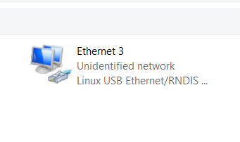

Figure 1: Linux USB Ethernet/RNDIS Gadget.

1. Select the network you are currently using to connect to the internet. This will most likely be either Local Area Connection, Ethernet, or Wireless. Right-click the selected network and choose Properties from the pop-up menu.
2. Select the Sharing tab from top of the new screen and select the check box labeled Allow Other Network Users to Connect Through This Computer’s Internet Connection” (**Figure 2**).

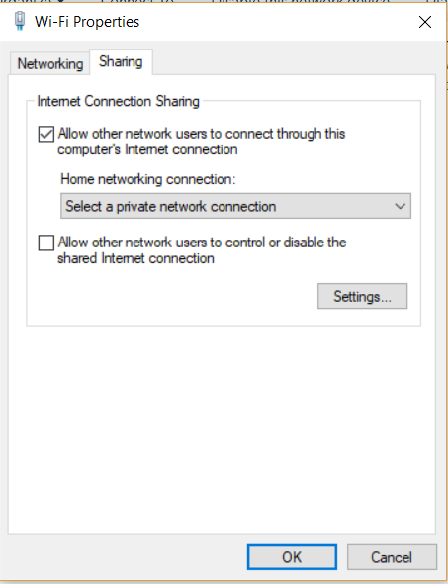

Figure 2: Network Sharing Tab.

1. From the drop-down box below this, select the name of the network connection associated with the Linux USB Ethernet/RNDIS Gadget. Press OK at the bottom of the dialog box.

# Reset the Default Gateway

Once you’ve completed this portion, you may notice that your SSH connection to the PocketBeagle/BeagleBone is disrupted and does not reconnect. For some reason after completing the network sharing, the default gateway address assigned by Windows is incorrect and will need to be fixed:

1. Once again in your network connections, right-click on the PocketBeagle/Beaglebone’s network connection and select Properties.
2. Select Internet Protocol Version 4 (TCP/IPv4) and click Properties (**Figure 3**).

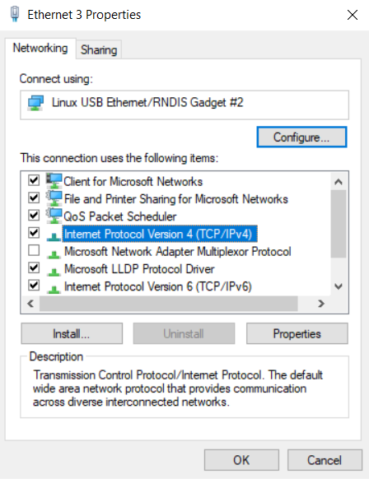

Figure 3: PocketBeagle IP Configuration.

1. Change the IP address shown to 192.168.7.1 and click OK at the bottom.

# Configure the Server Name

Give it just a moment to update and reconnect. Then you should be able to ping any IP address such as 8.8.8.8; however, if you try pinging something like www.google.com, you will get an error. We need to configure a name server which will allow us to translate a name to an IP address:

1. Type sudo nano /etc/resolv.conf. This will open up an editor screen.
2. Add the following lines of code to the editor:
   * nameserver 8.8.8.8
   * nameserver 8.8.4.4
   * nameserver 192.168.7.1
3. Press Ctrl-X to exit and press Y to save.

Once these steps are complete, you should be able to ping addresses such as google.com and receive a response.

# Add a Start Script

Anytime you unplug or reset the device, you will need to re-setup your default gateway and name servers. On the [Mouser Electronics Github](https://github.com/Mouser-Electronics/Pocket-Arcade) page, you’ll find a script called StartUSBNetwork.sh that will automatically set these for you. Now that your network is setup, you can grab this by typing the following:

1. sudo wget https://github.com/Mouser-Electronics/Pocket-Arcade/blob/master/StartUSBNetwork.sh
2. sudo apt-get install ntpdate
3. sudo chmod +x StartUSBNetwork.sh

Now every time you reboot your system, you will simply need to type sudo ./StartUSBNetwork.sh.

**Note:** I’ve included ntpdate in the script to help update the time and date every time the script runs. This is why the step for installation is included.